Java Environment Setup (Windows 11)
To get started, we need to download the JDK from Oracle. This kit contains the compiler we need to turn our source code into something the computer can run.
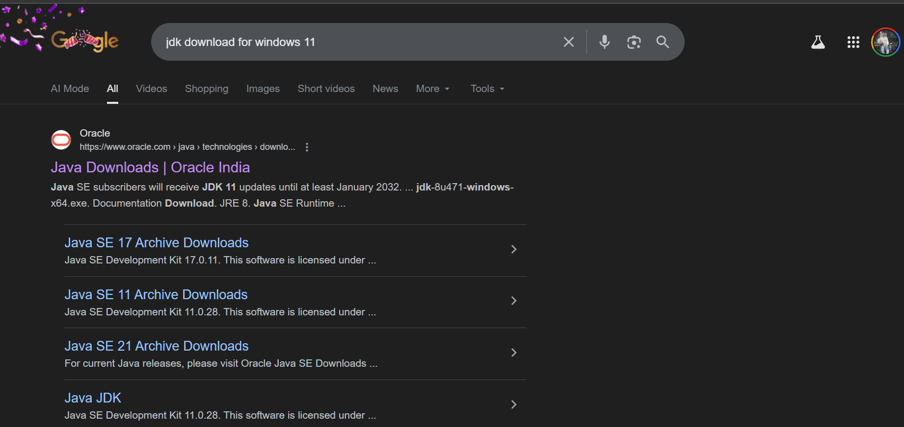

Once on the Oracle site, make sure you are in the JDK 21 section (this is a standard version can download jdk17 version also ).
- Click the Windows tab.
- Locate the x64 Installer row and click the download link (the .exe file).
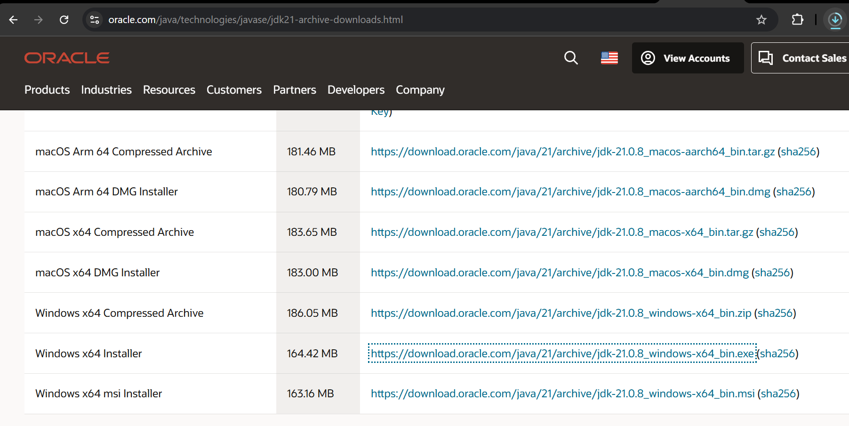

Now that we have the file, we need to run it. This process is standard for most Windows applications.
- Open the downloaded file.
- When the "Welcome to the Installation Wizard" screen appears, click Next.

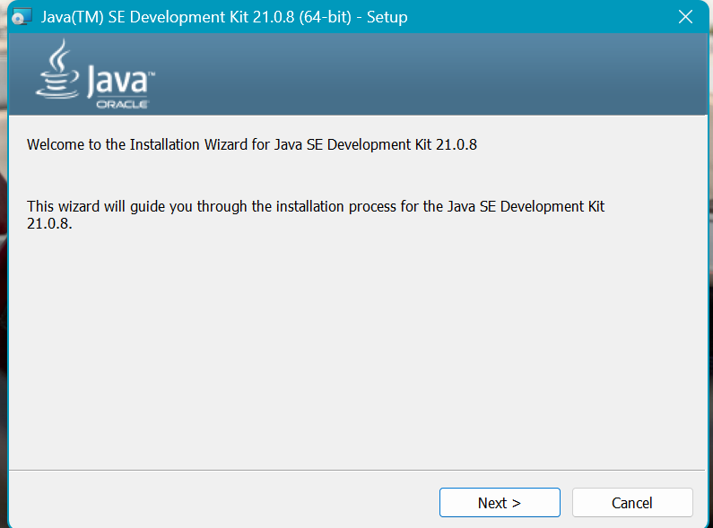
- Follow the prompts .
- Once the progress bar finishes, you will see a "Successfully Installed" message.
- Click Close.

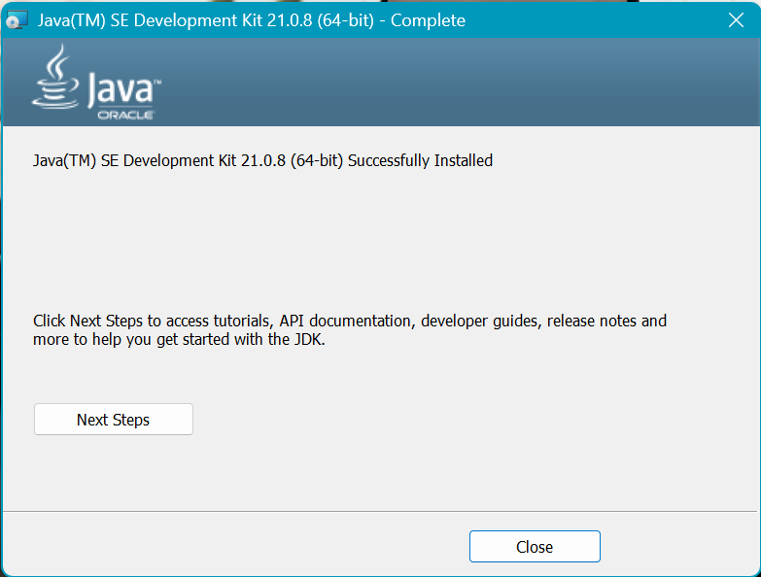
Verify the Compiler (javac)
- Open Command Prompt.
- Type javac -version and press Enter.
- Success: You should see javac 21.0.8.

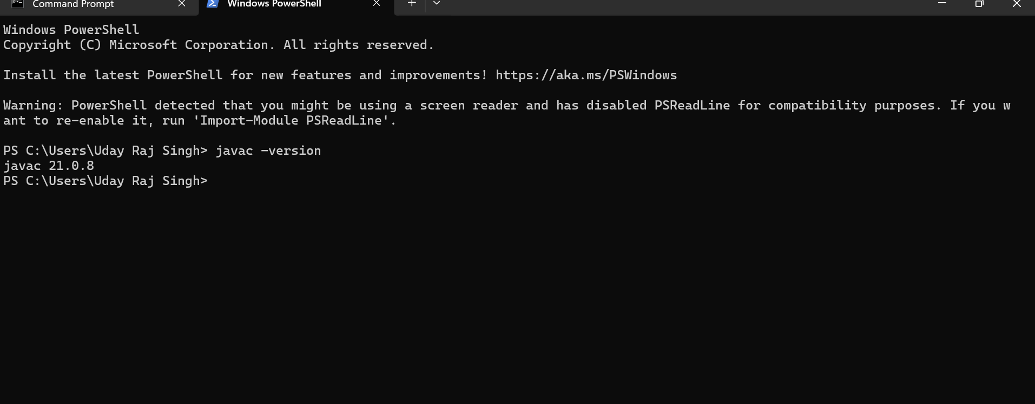
Verify the Runtime (java)
- Now, type java -version and press Enter.
- Success: You should see details about the "Java HotSpot(TM) 64-Bit Server VM".

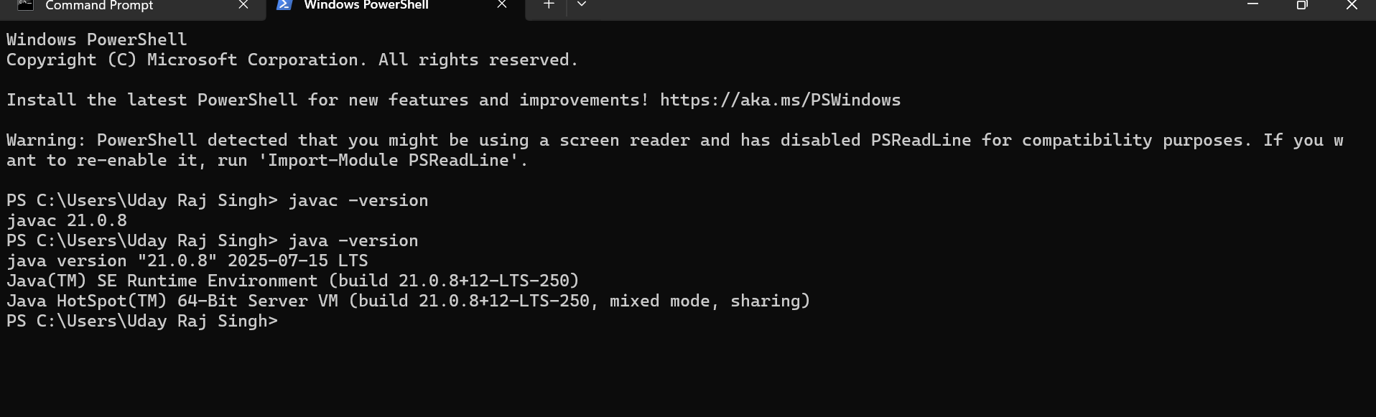
If you type javac -version and receive the error message:
"'javac' is not recognized as an internal or external command, operable program or batch file."
This means Windows does not know where the Java tools are located. We need to manually tell Windows where to look by updating the Environment Variables.
Solution: Add Java Path Manually
Step 1: Copy the Bin Path
- Open File Explorer and go to your installation drive (usually C:).
- Navigate to Program Files > Java > jdk-21.0.8.
- Open the bin folder.
- Click inside the address bar at the top, copy the full path.
  - It should look like this: C:\Program Files\Java\jdk-21.0.8\bin
Step 2: Open Environment Variables
- Press the Windows Key and search for "env".
- Select "Edit the system environment variables".
- In the small window that pops up, click the "Environment Variables..." button at the bottom right.
Step 3: Edit the "Path" Variable
- In the bottom section labeled System variables (not User variables), scroll down and find the variable named Path.
- Select Path and click the Edit button.
- Click New on the right side.
- Paste the path you copied earlier (C:\Program Files\Java\jdk-21.0.8\bin).
- Click OK on all three open windows to save the changes.
Step 4: Restart and Retry
- Important: You must close your existing command prompt or PowerShell window and open a new one for the changes to take effect.
- Type javac -version again. It should now show the version number.

